**SessionFactory – One instance per application.Create sessions**

**Session – Conversation between application and Hibernate.**

**Transaction Factory – Creates transactions to be used by application**

**Hibernate is an ORM Tool.**

**Hibernate is much more than ORM Tool, but started as an ORM Tool.**

**-Used in the data layer of applications**

**-implements JPA (Java Persistence API)-If you don’t want to use Hibernate , can use JPA**

**The problem**

|  |
| --- |
| **User Class** |
| **ID** |
| **Name** |
| **Address** |
| **Phone** |
| **Date of Birth** |

**Object**

|  |  |  |  |  |
| --- | --- | --- | --- | --- |
| **ID** | **Name** | **Address** | **Phone** | **DOB** |
|  |  |  |  |  |
|  |  |  |  |  |
|  |  |  |  |  |
|  |  |  |  |  |
|  |  |  |  |  |

**Relational**

**Mapping**

**Class corresponds to a table & object corresponds to a row.**

**User object 1 as row no 1**

**User object 2 as row no 2**

**In java it is object but in database it is not a object. Mapping is a pain.**

**The problem**

1. **Mapping member variables to column**
2. **Mapping relationships**

**e.g. User objects has reference of Address object**

**3) Handling data types**

**e.g. most of the databases doesn’t have Boolean data type, want to store active user(true/false) need to convert yes/no form manually.**

**4)Managing changes to object state.**

**-update query**

**To download jar file hibernate.org/downloads**

**Realease bundle**

**Add required jar files 1) hibernate jar 2)database jar**

**Steps for adding jar files**

**-Build path- configure build path-libraries-add library-user library-next-user libraries-new-write down say hibernatejars-ok-add external jars –select required jars-ok-finish-ok.**

**Expand your project & check the jar files you added.**

**Saving without Hibernate**

**--------------------------------------**

**-JDBC database configuration**

**-The Model object**

**-Service method to create the model object**

**-Database design**

**-DAO method to save the object using SQL queries**

**Hibernate Way**

**-JDBC Database Configuration – Hibernate configuration(xml file)**

**-The Model object - Annotations**

**-Service method to create model object – use the Hibernate API**

**-Database design – not needed(Hibernate creates the table itself**

**- & biggest challenge of mapping**

**DAO method to save the object using SQL queries – Not needed.**

**…..write sql queries –no need**

**Code**

**Hibernate.cfg.xml(default)**

**-u can give yr name also ,but in that case u need to pass your filename in configuration.**

**Dialect settings depend on database.**

**-it is kind of configuration So hibernate knows the language**

**-since we are not writing SQL queries Hibernate should know sql dialect.**

**-class in Hibernate specific to database. (common query to all database)**

**Using the Hibernate API**

**-create a session factory**

**SessionFactory ss=new Configuration().configure().buildSessionFactory();**

**-create a session from session factory**

**Session session=sessionFactory.openSession();**

**-use the session to save model objects**

**Hibernate configuration file**

**-Drop and recreate the database schema on start up**

**<property name=”hbm2ddl.auto”>create</property>**

**In this case if you insert one more data, it drops existing table create a new one.**

**So If you want to insert data in existing table write update instead of create**

**-Echo all executed SQL to stdout**

**<property name=”show_sql”>true</property>**

**<!—Names the annotated entity class 🡪 List out all model classes**

**<mapping class=”org.hibernate.tutorial.annotations.event”/>**

**User is keyword in most of databases. User is not allowed as a database.**

**-Annotation**

**At least 2 annotations need to be used in Model class – Id and Entity**

**You can write down annotations either on top of fields or getter methods.**

**@Entity (name=”USER_DETAILS”)**

**Public class UserDetails**

**{**

**@Id**

**@Column (name=”user_id”)**

**Private int userId;**

**@Column(name=”user_name”)**

**Private String username;**

**OR**

**With getter method :-**

**@Id**

**@Column(name=”user_id”)**

**Public String getUserId()**

**{ return userid +”From getter method inserting text”;}**

**-instead of @Entity (name=”USER_DETAILS”) you can use @Table(name=”User_Details”),**

**Using both ways we can change table name.**

**Entity name you can refer while using HQL?**

**-Id,Column,Entity, Table all these annotations are part of javax.persistence.*;**

**-If you don’t want to create a column just mark the column static or transient.**

**e.g.**

**@Transient**

**Private String userName;**

**-Date column is stored as timestamp in database as a by default. If you want different datatype**

**@Temporal (TemporalType.DATE)**

**Private Date joinedDate**

**TemporalType is a enumeration that has one of the value DATE**

**If you want to store only time write @TemporalType.Time**

**Hibernate by default uses TimeStamp for Date type.**

**-Hibernate by default uses varchar2(255) in case of String and if you want to store more info exceeding 255 chars. Then**

**@Lob**

**Private String description**

**@Lob takes automatically either CLOB (character) or BLOB(Bytestream)**

**@Basic – just go ahead as it is-**

**Two options are there with @Basic –optional and fetch, if u want to use this option use it otherwise no need to write.**

**Persist ⬄Save**

**-Sessionfactory object is created only once per application. And all your classes and methods share the same , so create as an static utility method.**

**- Retrieving model from database**

**Account=null;**

**Session = sessionFacotry.openSession();**

**Session.beginTransaction(); //group all transactions ,can do multiple things**

**Account account=(Account)Session.get(Account.class,accountNumber)**

**System.out.println(“User details “+account.getUserName());**

**In xml file option should be create**

**Other ways to retrieve data 2) HQL Hibernate query language 3)SQL query**

**First parameter – table**

**Second parameter – primary key value**

**@Id is for primary key , @Generated – automatically add the values in a column, no need to accept/set value from user.**

**@Generated has some strategy – AUTO(default),IDENTITY,SEQUENCE ,TABLE**

**TABLE – Hibernate is going to create separate table and generates the value.**

**@Id@GeneratedValue(strategy=GenerationType.AUTO)**

**AUTO – Let Hibernate take decision**

**IDENTITY – Use with sql server/mysql(check)**

**TABLE – Hibernate is going to create a new table & generate the entry.**

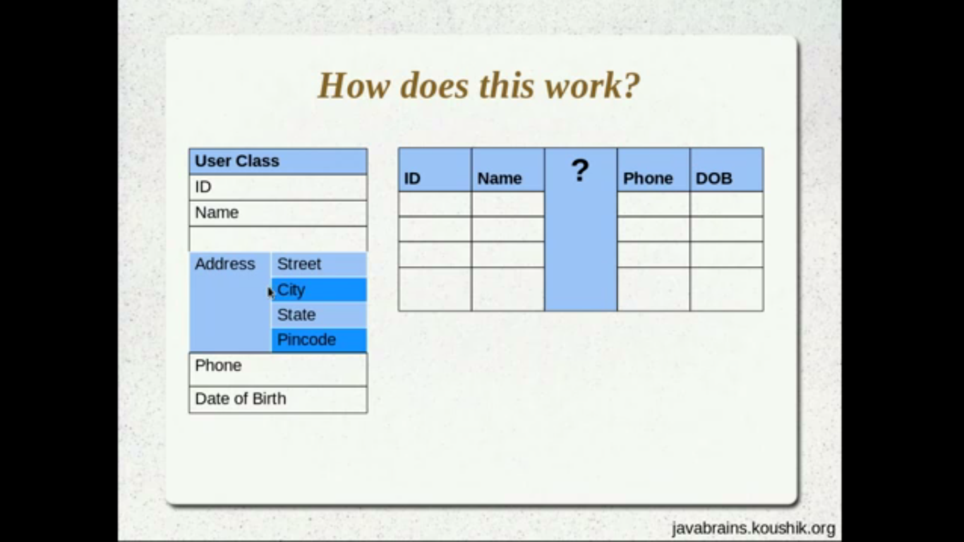

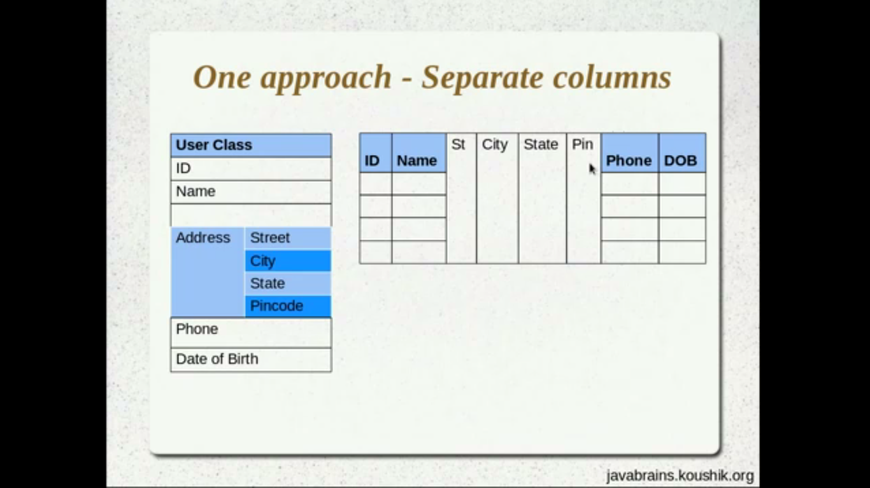

**User class – Entity object**

**Address – Value object**

**Value object doesn’t have meaning of its own.**

**Even other fields like name, phone.. are also value objects .**

**-In order to mark value objects: create separate class of Address mark it @Embeddable**

**And inside UserDetails class – one of the member variable**

**@Embedded // optional**

**Address address**

**with getter and setter methods.**

**-If you want to give own column name in embeddable object.**

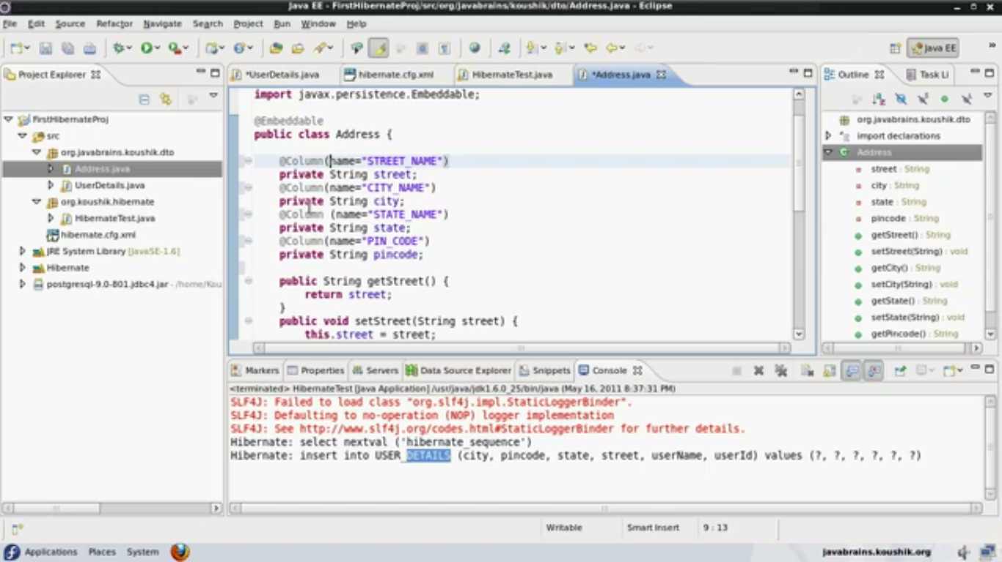

**i.e. above the column name**

**@Column(name=”STREET_NAME”)**

**Private String street;**

**-Next scenario**

**@Embedded**

**Private Address homeAddressl**

**@Embedded**

**Private Address officeAddress**

**Solution :**

**@Embedded**

**@AttributeOverride(name=”street”, Column=@Column(name=”Home_Street_Name”) )**

**Private Address address**

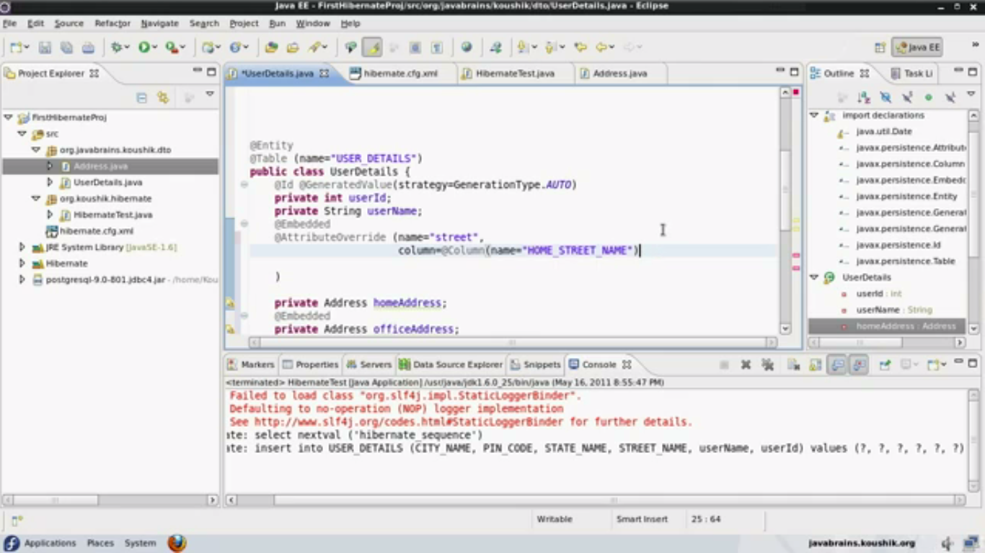

**If you want to set multiple column names then you need to override**

**@AttributeOverrides**

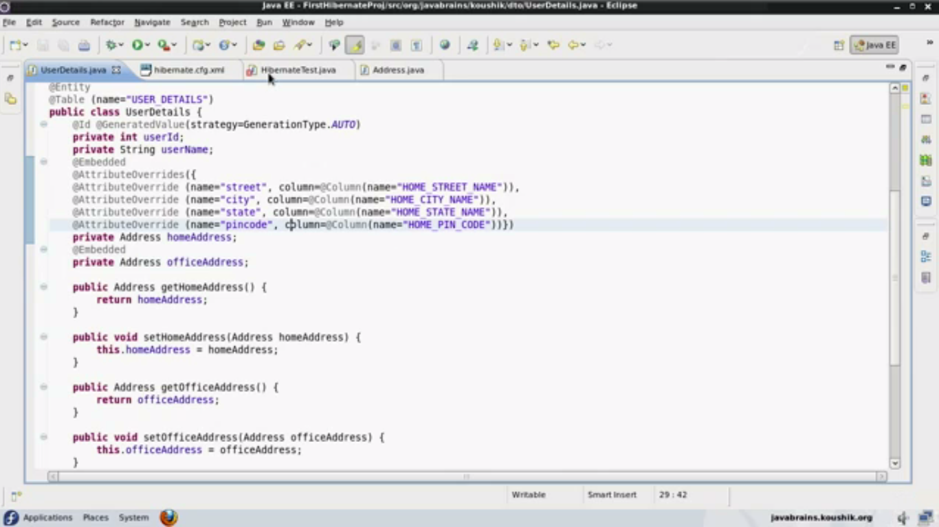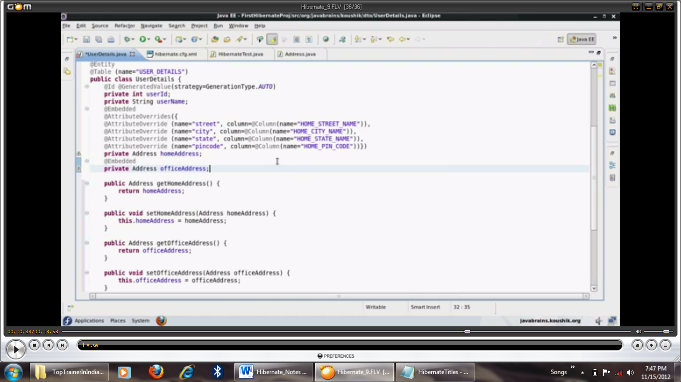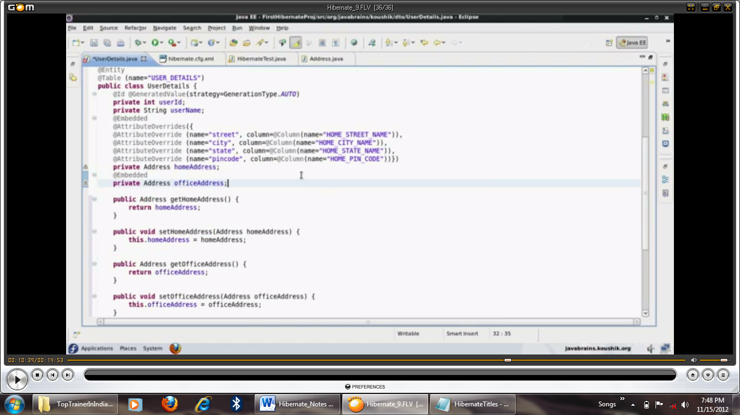

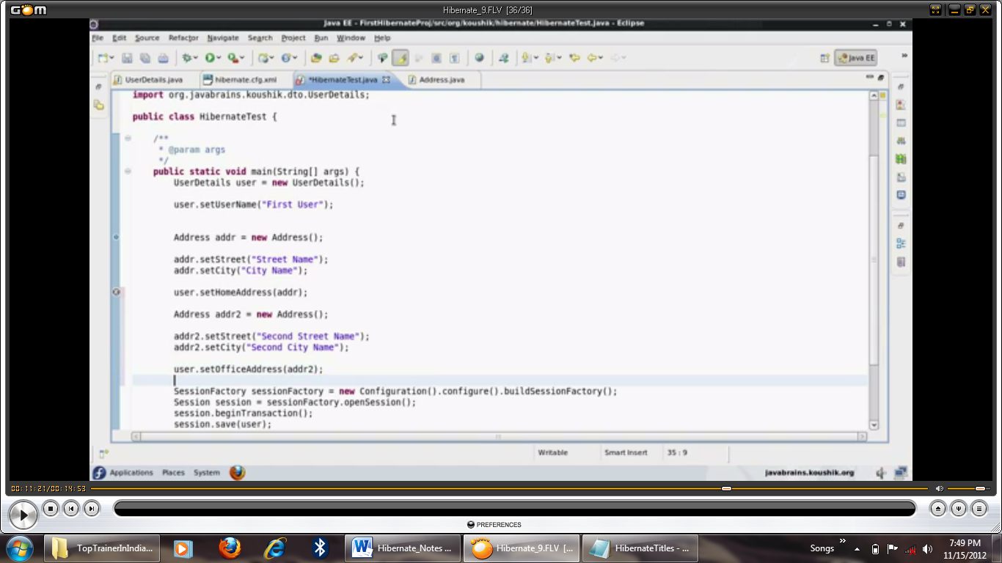

**-You can have separate userid value objects also but in that case primary key value cannot be generated**

**e.g.**

**@EmbeddedId**

**Private LoginName userId;**

**Then of course you can use attributoverrides to assign different name for different objects.**

Collection

**-You can have collection to be member variable, don’t know how many address object is required.**

**@ElementCollection**

**Private Set<Address> listOfAddresses=new HashSet();**

**Considers separate tables by marking @ElementCollection**

**We always declare like Collection/Set- reason related to eagar & lazy loading**

**@ElementCollection is not working use** @CollectionOfElements

**And getter and setter methods**

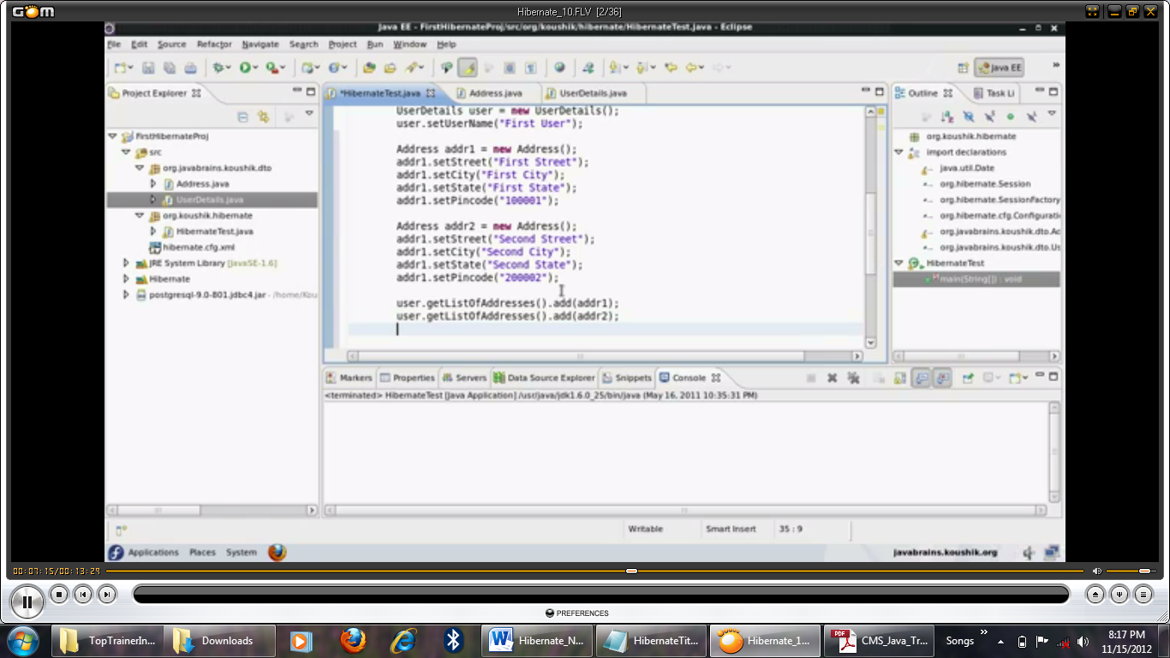

**In this case Another table is created name it – Userdetails_listofaddress where userdetails is a class name and listofaddresses is objects of Set.**

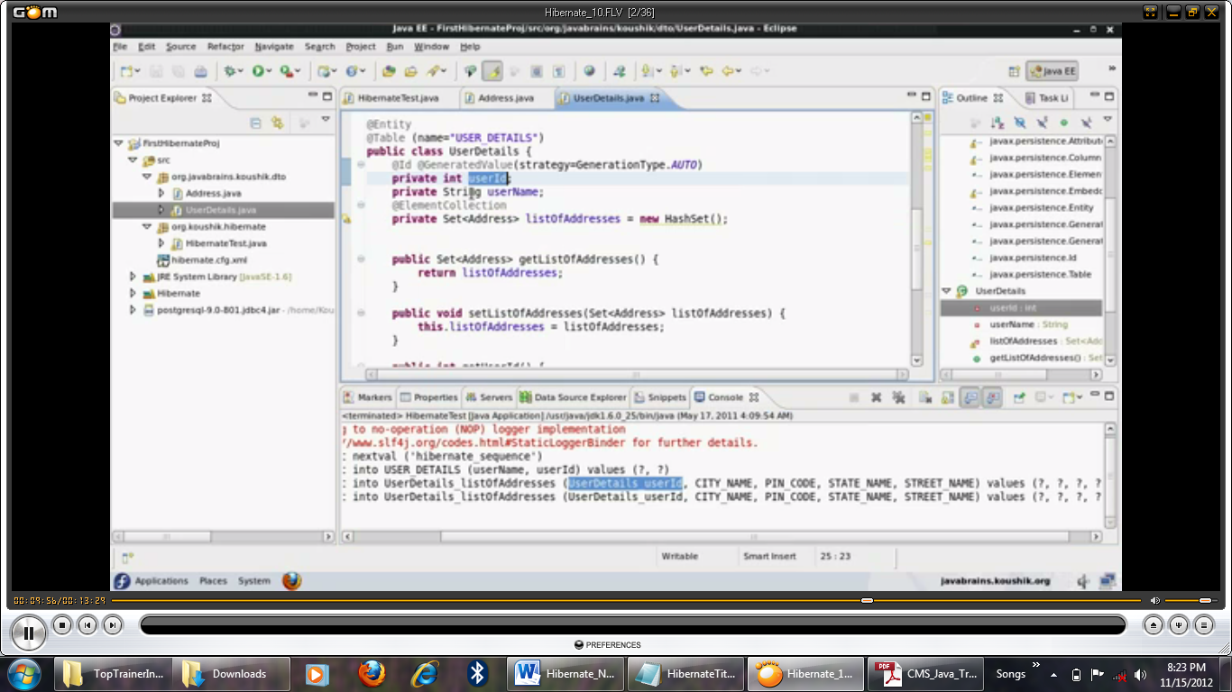

**Changing collection table name using @JoinTable(name=”USER_ADDRESS”)**

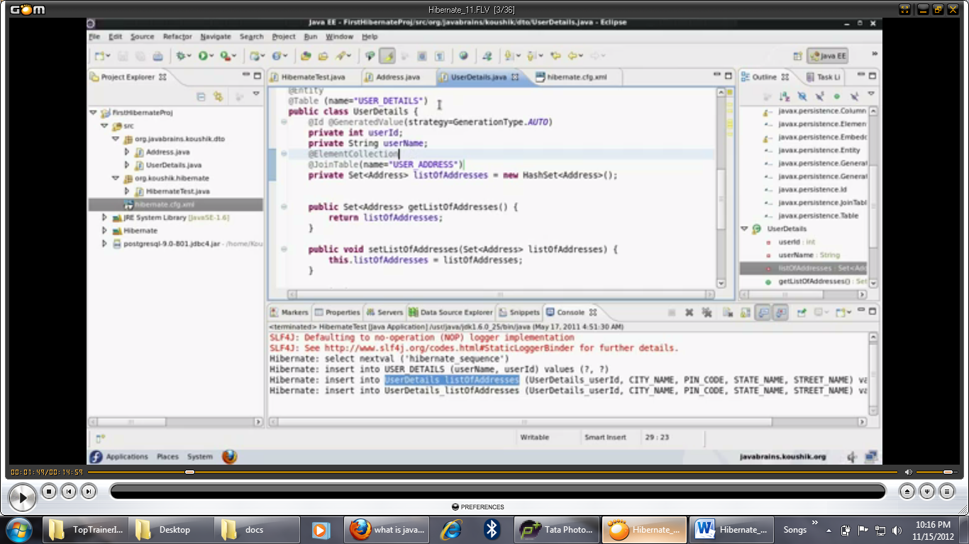

**To change primary key column name**

**-@JoinTable(name=”USER_ADDRESS”, JoinColumns=@JoinColumn(name=”USER_ID”)**

**@CollectionId is specific to Hibernate and not part of JPA, belongs to org.hibernate.annotations.CollectionId.**

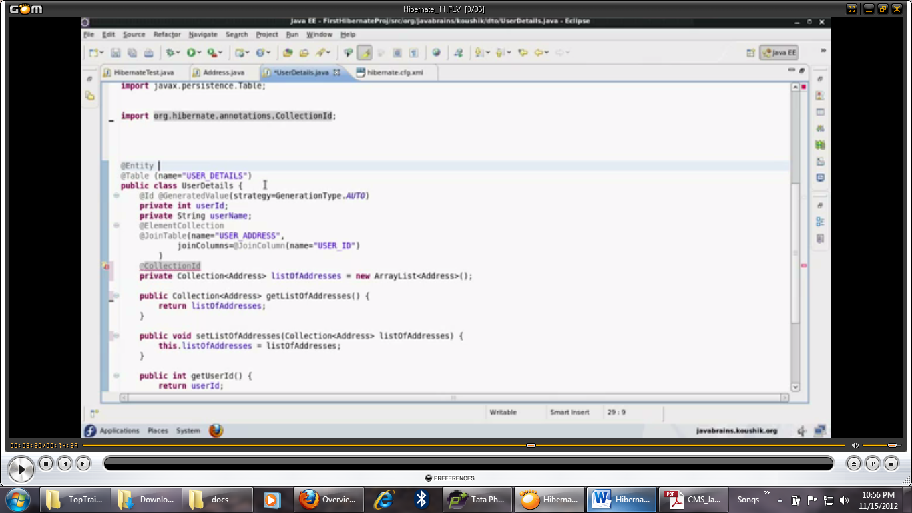

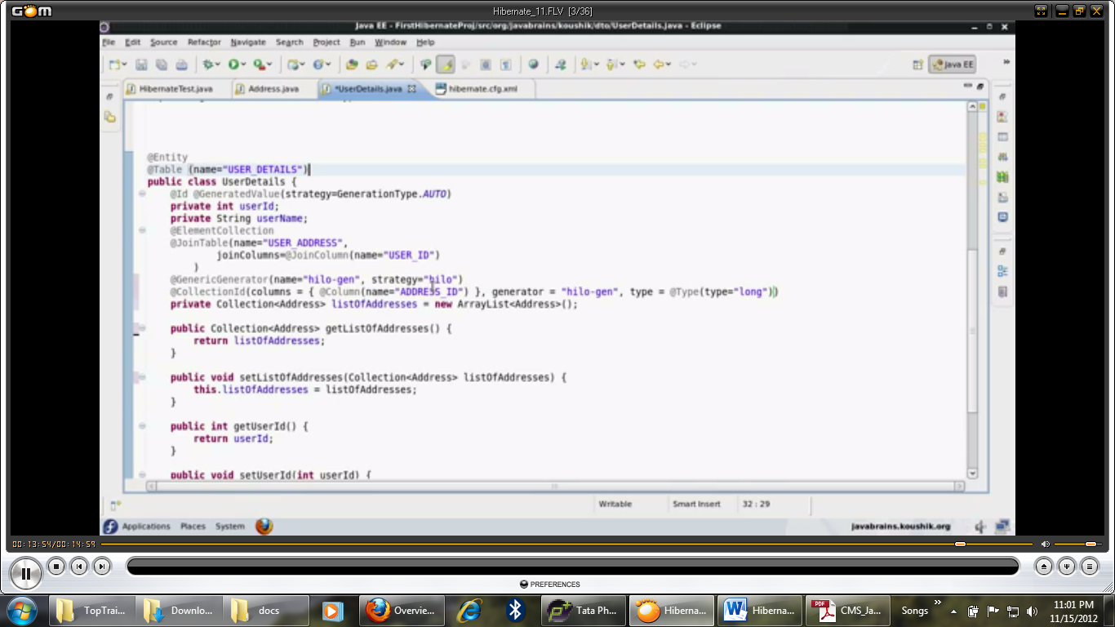

**Result in database(postgres) autogenerated index column in user_address table**

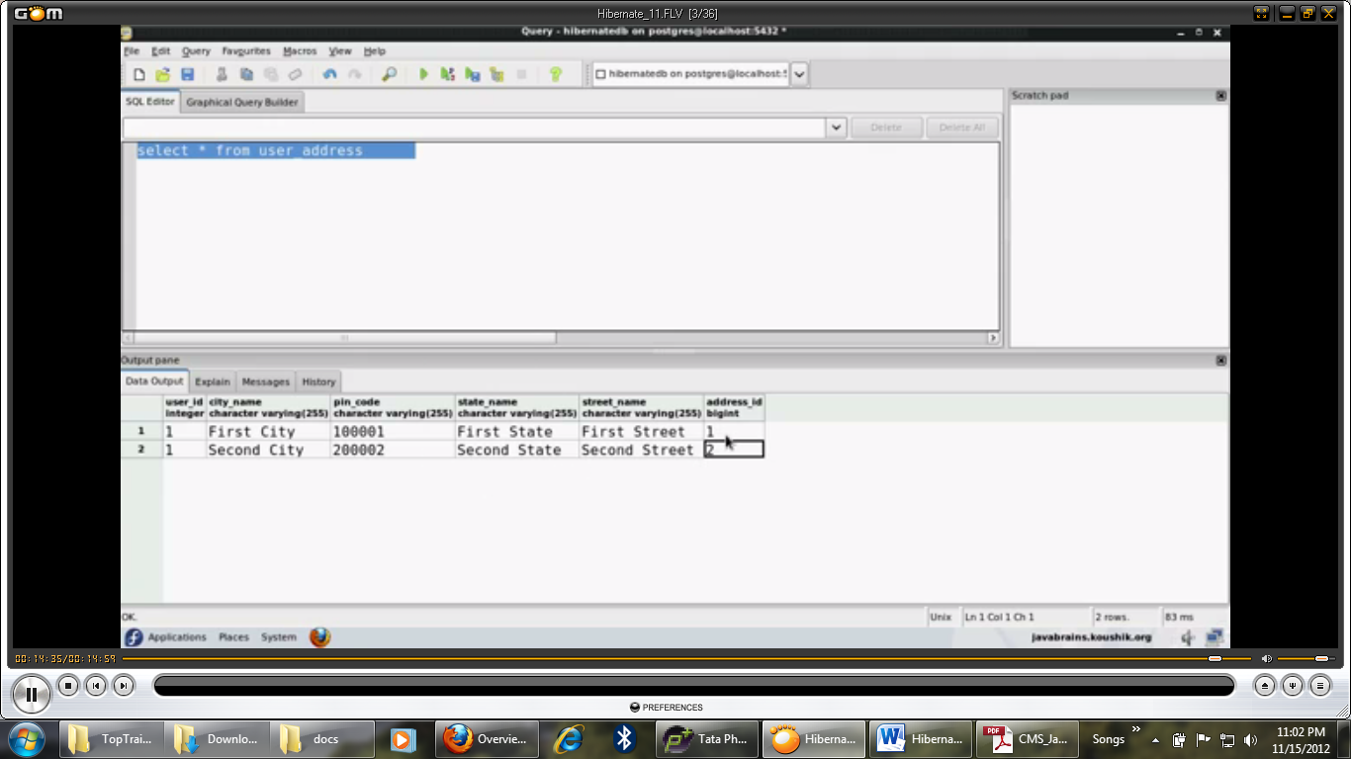

**One-To-One relationship**

**-last time we have used value object inside Entity.**

**-In this one, we have Entity inside another Entity.**

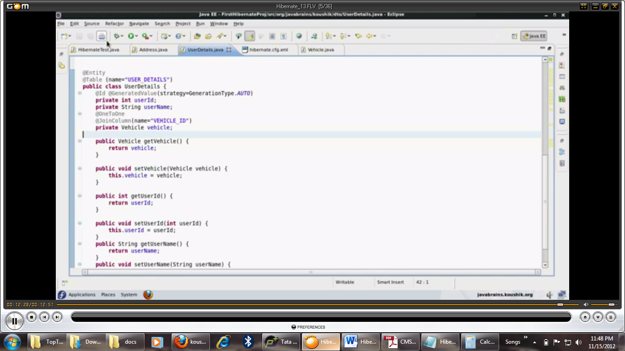

**One-To-Many**

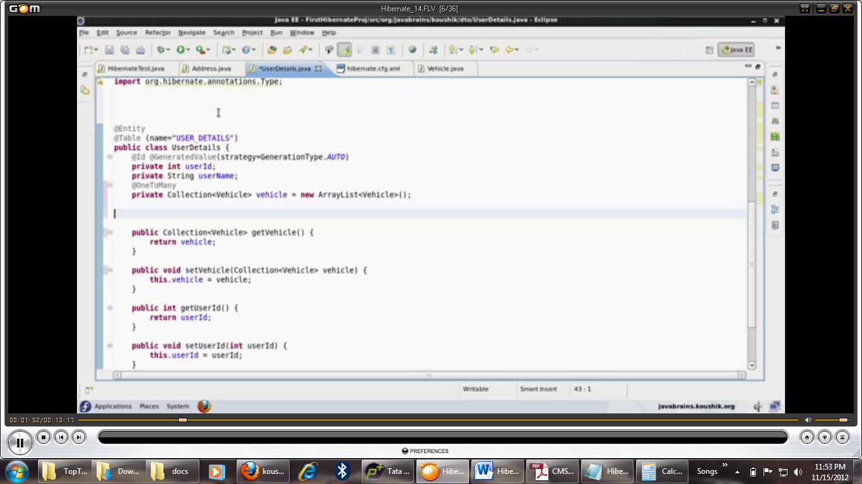

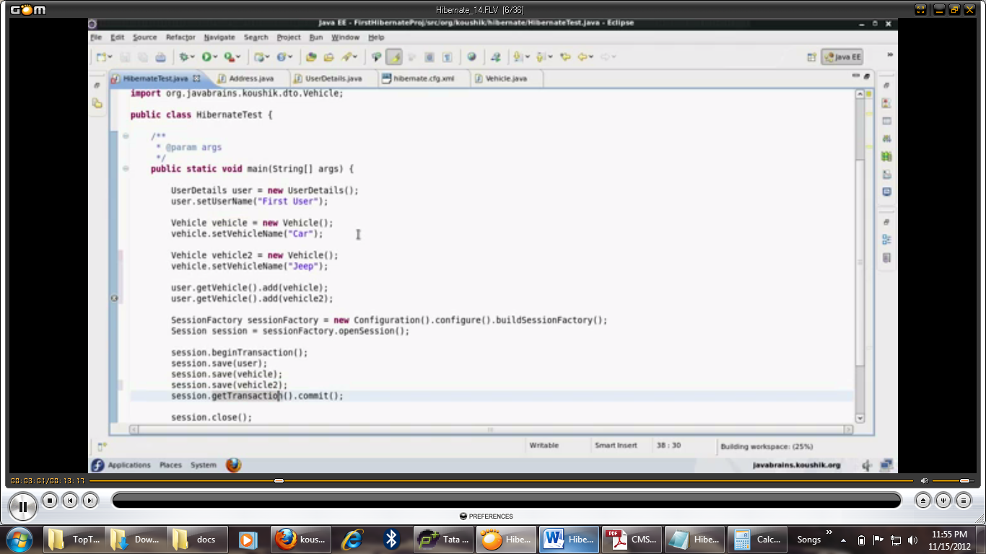

**Result in database**

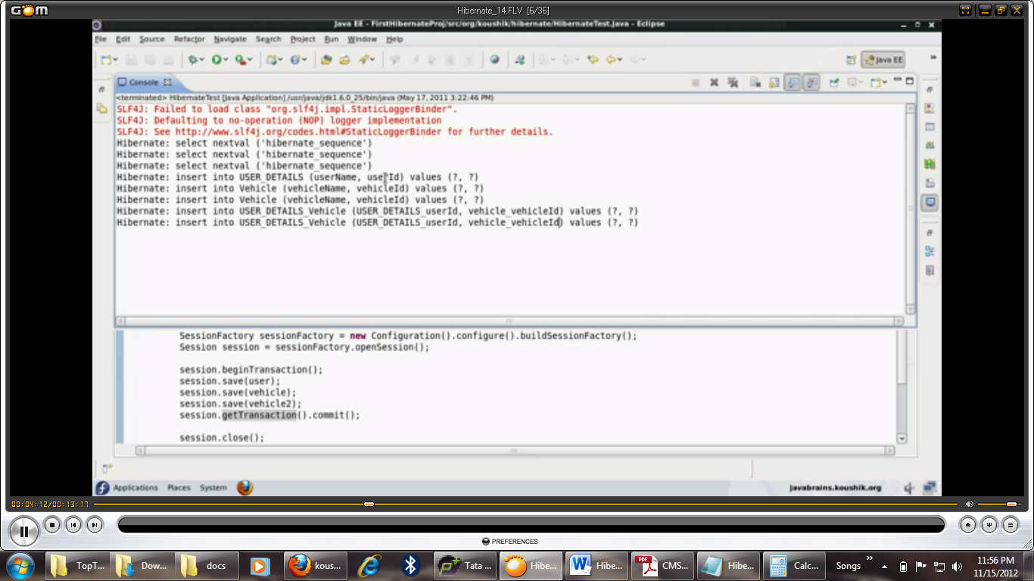

**Many-To-One relationship**

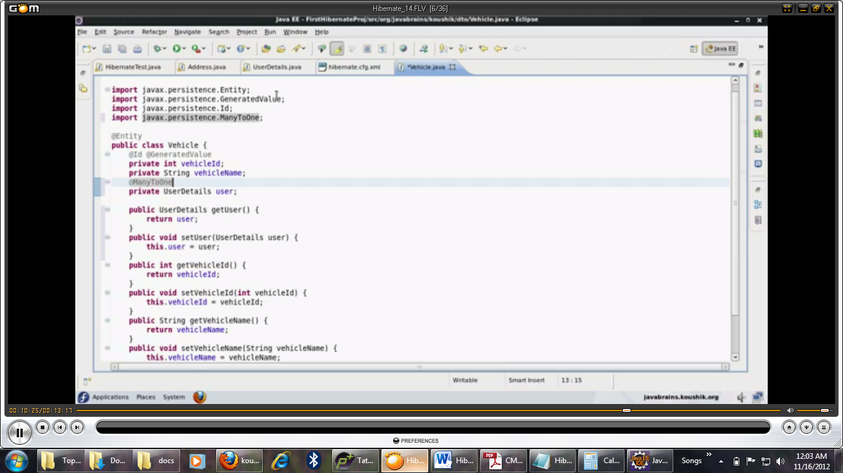

* **We don’t require discriminator if there is table per class strategy**

**UserDetails**

**@OneToMany(mappedBy=”user”)**

**Vehicle**

**@ManyToOne**

**@JoinColumn(name=”USER_ID”)**

**Private UserDetails user;**

**-Read operation**

**Update option in xml ,**

**After session.beginTransaction();**

**UserDetails user=(UserDetails)session.get(UserDetails.class,6);**

**System.out.println(user.getUserName());**

**-Delete operation**

**After session.beginTransaction();**

**UserDetails user=(UserDetails)session.get(UserDetails.class,6);**

**Session.delete(user);**

**-Update operaton**

**After session.beginTransaction();**

**UserDetails user=(UserDetails)session.get(UserDetails.class,5);**

**Session.setUserName(“updated user”);**

**Session.update(user);**

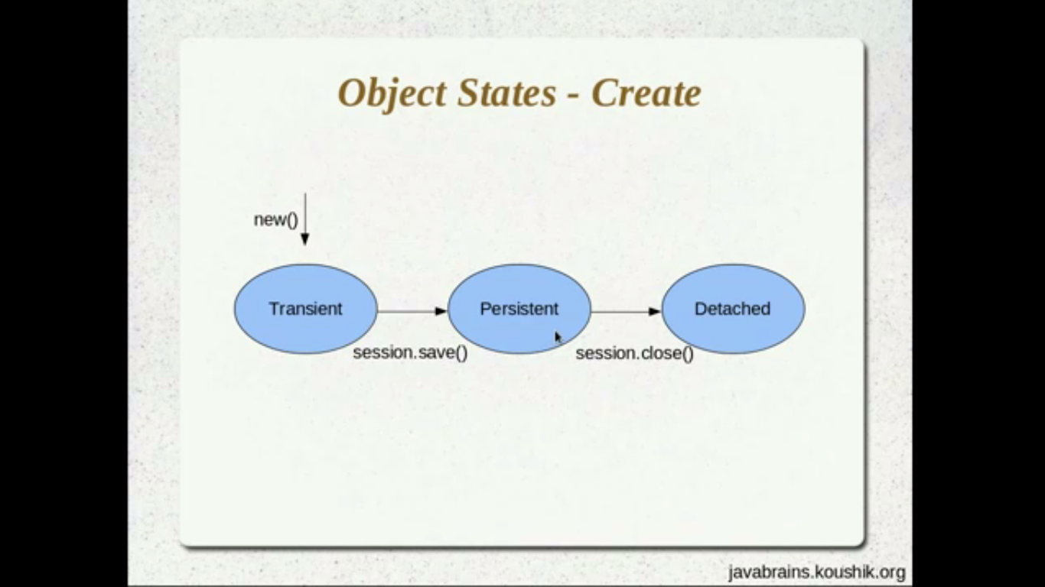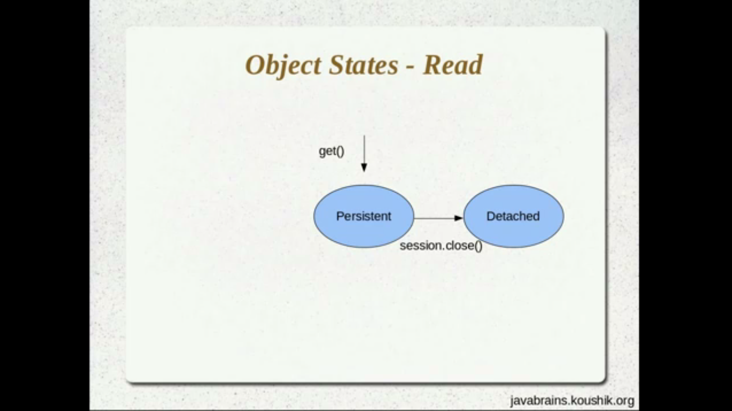

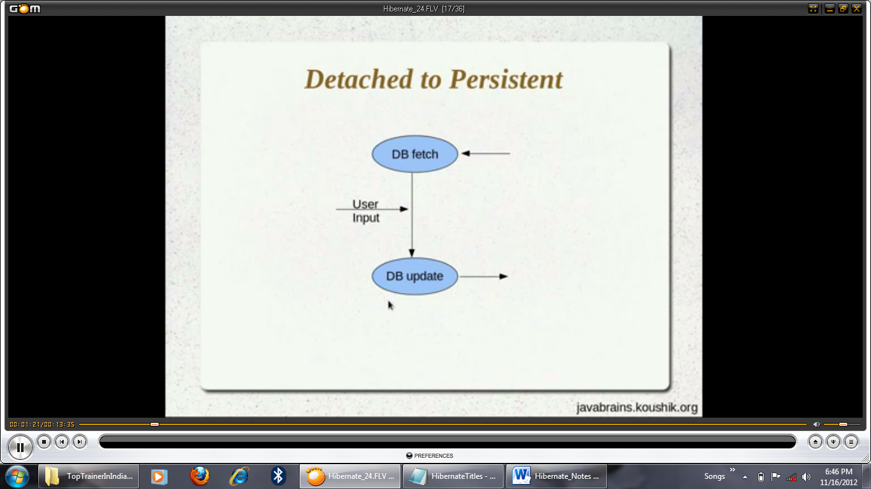

**Code for Detached to Persistent**

**Main()**

**{**

**SessionFactory sessionFactory=new Configuration().configure().buildSessionFactory();**

**Session session=sessionFactory.openSession();**

**Session.beginTransaction();**

**UserDetails user=(UserDetails)session.get(UserDetails.class,1);**

**session.getTransaction().commit();**

**session.close();**

**user.setUserName(“updated user name after session close”);**

**Session=sessionFactory.openSession();**

**session.update(user);**

**// user.setUserName(“change after update”); //persistent**

**session.getTransaction().commit();**

**session.close();**

**And change the setting in hibernate configuration file update instead of create**

**HQL**

After session.beginTransaction();

Org.hibernate.Query query=session.createQuery(“from userdetails”);//no select *, it is HQL

//userdetails is a class name instead of table name.

Java.util.List users=query.list();

//can use generic also as follow

//List<UserDetails> users=(List<UserDetails>)query.list(); as it is returning only list so we require casting.

Session.getTransaction().commit();

Session.close();

System.out.println(“Size of list result “+users.size());

Or display record

For(UserDetails u:users)

System.out.println(u.getUserName);

Ensure “update” option should be hibernate configuration file.

* Where clause
* Org.hibernate.Query query=session.createQuery(“from userdetails where userid>5”);

**Difference between SQL and HQL**

**1)HQL uses classname instead of tablename**

**2) HQL uses fieldname instead of columnname**

**3)no select * in HQL**

**4) return type for (* from userdetails) is list.**

**Pagination**

Org.hibernate.Query query=session.createQuery(“from userdetails”);

query.setFirstResult(5); //starting poing

query.setMaxResults(4);//fetching no of records

selecting specific columns

Query query=session.createQuery(“select username from userdetails”);

This doesn’t return list because we are selecting only one column username.

List<String> userNames=(List<String>)query.list();

For(String s:userNames)

System.out.println(s);

Another way

Query query=session.createQuery(“select new map(userId,username) from userdetails”);

Select max(userId) from userdetails

-query without hardcoding

Int minUserId=5;

Query query=session.createQuery(“select username from userdetails where userid>”+minUserId);

**Above query may cause security problem**

**String minUserId=”5 or 1=1”;**

**Which returns all rows**

**-passing parameter**

**String minUserId=”5”;**

**Query query=session.createQuery(“Select * from userdetails where userId>?”);**

**Query.setInteger(0,Integer.parseInt(minUserId); //positional parameter , u can have n no of placement holder as ?**

**-can pass named parameter instead of ? and instead of positional parameter you need to use named parameter**

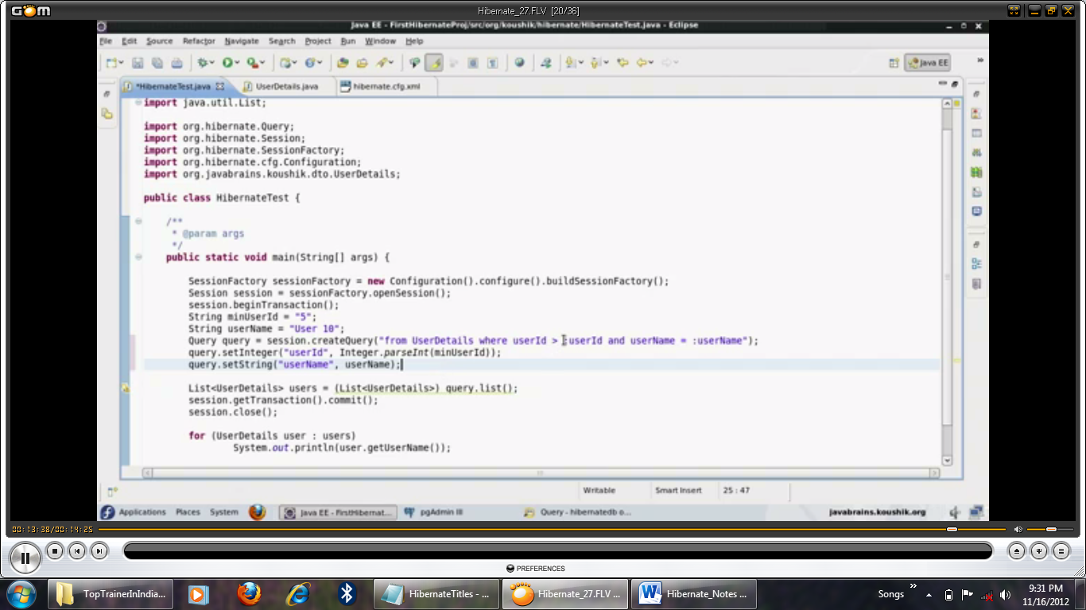

**Above approach is safer way.**

**-Named queries- allows you to write down query at Entity level.**

**Above the class & below @Entity**

**@NamedQuery(name=”userdetails.byId”, query=”from userdetails where userid=?”)**

**Then from the query**

**Query query=session.namedQuery(“userdetails.byId”);**

**Query.setInteger(0,2);// can use positional or named parameter**

**@NamedNativeQuery(name=”userdetails.byusername” query=”select * from user_details where username=? ”,resultClass=UserDetails.class)**

**In this case user_details is a table name not classname as in the previous case. In case of HQL query Hibernate knows return type but in case of native query Hibernate doesn’t know return type so specifying as a third parameter return type.result class is optional.**

**Query query=session.namedQuery(“userdetails.byusername”);**

**Query.setString(0,”user 10”);//**

**-There are 3 ways to extract data**

**1)session.get**

**2)HQL**

**3)Criteria API**

**Criteria API**

**Criteria is like where clause**

**-not creating object of Query**

**Org.hibernate.Criteria criteria=session.createCriteria(UserDetails.class);**

**Criteria.add(Restriction.eq(“username”,”User 10”);//org.hibernate.criterion.Restriction**

**List<UserDetails> users=(List<UserDetails>)criteria.list();**

**Adding more restrictions**

**criteria.add(Restriction.eq(“username”,”User 10”);**

**.add(Restriction.gt(“userid”,5) //no need to write down criteria object once again.**

**.add(Restriction.like(“username”,”user%”)// no ; semicolon in multiple add(chaining)**

**.add(Restriction.between(“userid”,5,50);**

**In above case multiple add works like and operator**

**Can easily add n no. of restriction. Better in situation when HQL requires n no. of placement holder.**

**-applying or operator in criteria**

**Criteria.add(Restrictions.or(restrictions.between(“userId”,0,3),Restrictions.between(“userId”,7,10)));**

**Tablename and columnnames are case sensitive**

**-If you want to set multiple restriction/criteria it’s a painful job.In that case can user Example by Query.**

**e.g.**

**after session.beginTransaction();**

**UserDetails exampleUser=new UserDetails();**

**exampleUser.setUserId(5);**

**exampleUser.setUserName(“User 5”);**

**Example example=Example.create(exampleUser);**

**Criteria criteria=session.createCriteria(UserDetails.class)**

**.add(example);**

**In example, it doesn’t consider null and primary key value**

**Hibernate Cache**

**-if you fire 2 same update query, Hibernate intelligently fires the update query only once**

**Because of first level cache by session**

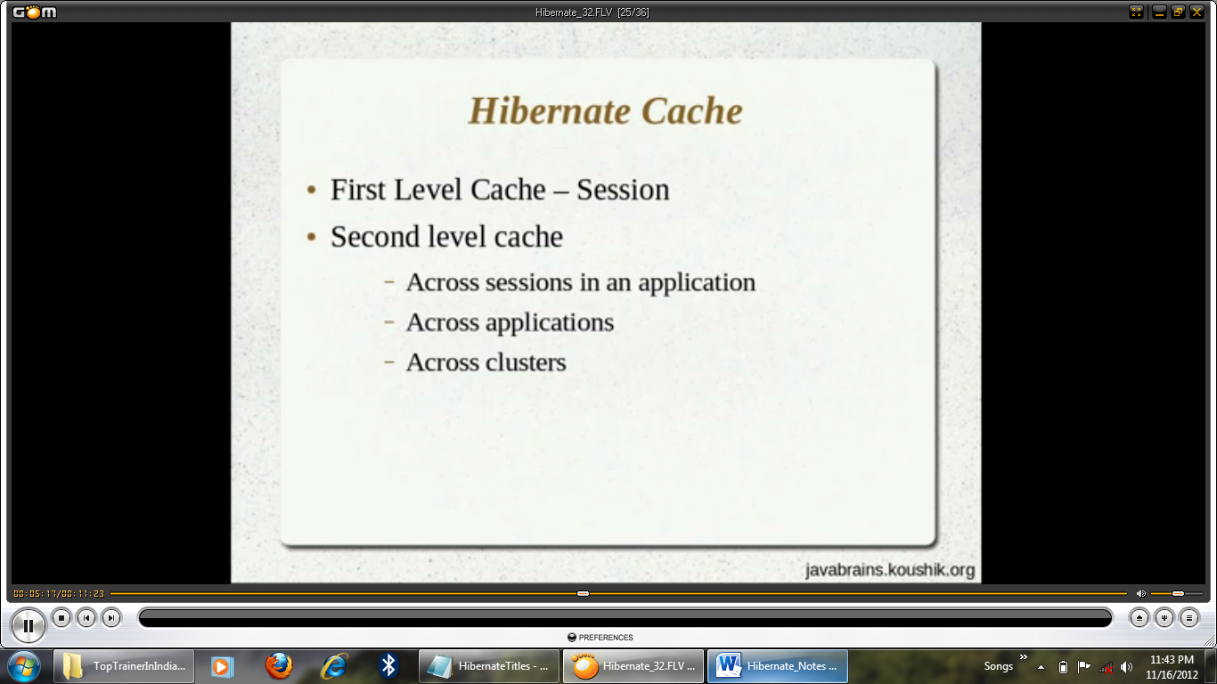

**First level cache demo**

**After session.beginTransaction()**

**UserDetails user=(UserDetails)session.get(UserDetails.class,1);**

**UserDetails user2=(UserDetails)session.get(UserDetails.class,1);**

**With above two statements Hibernate fires the query only once.**

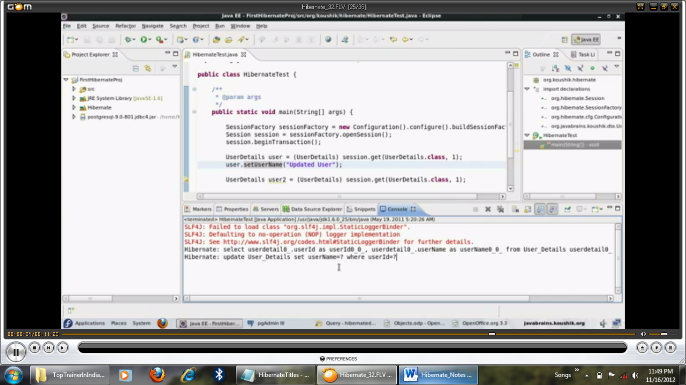

**-Next scanrio**

**After session.beginTransaction()**

**UserDetails user=(UserDetails)session.get(UserDetails.class,1);**

**User.SetUserName(“udated user”);**

**UserDetails user2=(UserDetails)session.get(UserDetails.class,1);**

**In above case as shown in picture it shows one select and update query**

**In multiple session if you fire the same query, it fires the query every time.**

**Since session is closed cache is also closed. Same picture as follow:**

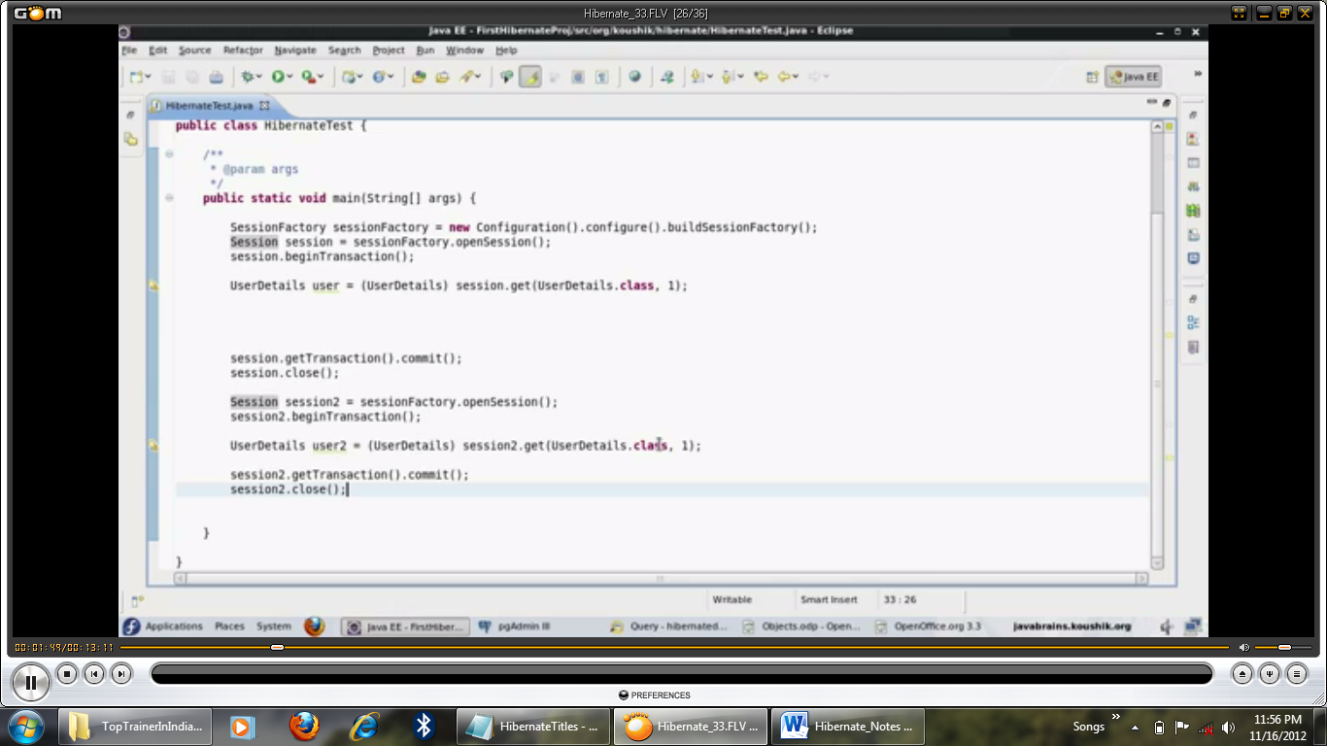

**Steps for Second level cache**

**<property name=”cache.provider_class”>org.hibernate.cache.NoCacheProvider</property>**

**Which means no cache provider**

**By default second level cache is off.**

1. **Hibernate configuration file**

**<property name=”cache.use_Second_level_cache”>true</property>**

<property name="hibernate.cache.use_second_level_cache">true</property>

**<property name=”cache.provider_class”>org.hibernate.cache.EhCacheProvider</property>**

**Need to download Ehcache-core.. jars**

1. **Below @Entity write @Cacheable from javax.persistence.Cacheable**

**Also you can write down strategy**

**@Cache(usage=CacheConcurrencyStrategy.READ_ONLY)**

**Hibernate is a high-performance Object/Relational persistence and query service which is licensed under the open source GNU Lesser General Public License (LGPL) and is free to download.**

**Hibernate not only takes care of the mapping from Java classes to database tables (and from Java data types to SQL data types), but also provides data query and retrieval facilities.**

**Pros and Cons of JDBC**

|  |  |
| --- | --- |
| **Pros of JDBC** | **Cons of JDBC** |
| * Clean and simple SQL processing * Good performance with large data * Very good for small applications * Simple syntax so easy to learn | * Complex if it is used in large projects * Large programming overhead * No encapsulation * Hard to implement MVC concept * Query is DBMS specific |

-Minimal locking by Hibernate framework

-First level caching(good performance)

e.g. suppose you require data from database say eno 25(primary key), once again if you fire the same query hibernate checks first in caching area, if the same record present, it retrieves from the same.

-Second level caching is also introduced for performance.

Database independance

-If you shift from mysql to Oracle u don’t require a single change in your coding. Only in configuration file make the changes of database details.

-Hibernate doesn’t require any application server like websphere, weblogic or JBoss(EJB requires the same),simply Tomcat Webserver is sufficient.

-In JDBC programmer has to write down checked exception, in ORM no need to write a single catch block.

-ORM Mapping object fields/properties to table columns.

-Lazy loading – working with proxy, not getting original object unless it uses…….

Hibernate architecture has three main components:

* **Connection Management**  
  Hibernate Connection management service provide efficient management of the database connections. Database connection is the most expensive part of interacting with the database as it requires a lot of resources of open and close the database connection.
* **Transaction management:**  
  Transaction management service provide the ability to the user to execute more than one database statements at a time.
* **Object relational mapping:**  
  Object relational mapping is technique of mapping the data representation from an object model to a relational data model. This part of the hibernate is used to select, insert, update and delete the records form the underlying table. When we pass an object to a **Session.save()** method, Hibernate reads the state of the variables of that object and executes the necessary query.

Hibernate is very good tool as far as object relational mapping is concern, but in terms of connection management and transaction management, it is lacking in performance and capabilities. So usually hibernate is being used with other connection management and transaction management tools. For example apache DBCP is used for connection pooling with the Hibernate.

Hibernate provides a lot of flexibility in use. It is called "**Lite**" architecture when we only uses the object relational mapping component. While in "**Full Cream**" architecture all the three component Object Relational mapping, Connection Management and Transaction Management) are used.

**Hibernate Advantages:**

* Hibernate takes care of mapping Java classes to database tables using XML files and without writing any line of code.
* Provides simple APIs for storing and retrieving Java objects directly to and from the database.
* If there is change in Database or in any table then the only need to change XML file properties.
* Abstract away the unfamiliar SQL types and provide us to work around familiar Java Objects.
* Hibernate does not require an application server to operate.
* Manipulates Complex associations of objects of your database.
* Minimize database access with smart fetching strategies.
* Provides Simple querying of data.

## Supported Databases:

Hibernate supports almost all the major RDBMS. Following is list of few of the database engines supported by Hibernate.

* HSQL Database Engine
* DB2/NT
* MySQL
* PostgreSQL
* FrontBase
* Oracle
* Microsoft SQL Server Database
* Sybase SQL Server
* Informix Dynamic Server

## Supported Technologies:

Hibernate supports a variety of other technologies, including the following:

* XDoclet Spring
* J2EE
* Eclipse plug-ins
* Maven

## Configuration Object:

The Configuration object is the first Hibernate object you create in any Hibernate application and usually created only once during application initialization. It represents a configuration or properties file required by the Hibernate. The Configuration object provides two keys components:

1. **Database Connection:** This is handled through one or more configuration files supported by Hibernate. These files are **hibernate.properties** and **hibernate.cfg.xml**.
2. **Class Mapping Setup**  
   This component creates the connection between the Java classes and database tables..

## SessionFactory Object:

Configuration object is used to create a SessionFactory object which inturn configures Hibernate for the application using the supplied configuration file and allows for a Session object to be instantiated. The SessionFactory is a thread safe object and used by all the threads of an application.

The SessionFactory is is heavyweight object so usually it is created during application start up and kept for later use. You would need one SessionFactory object per database using a separate configuration file. So if you are using multiple databases then you would have to create multiple SessionFactory objects.

## Session Object:

A Session is used to get a physical connection with a database. The Session object is lightweight and designed to be instantiated each time an interaction is needed with the database. Persistent objects are saved and retrieved through a Session object.

The session objects should not be kept open for a long time because they are not usually thread safe and they should be created and destroyed them as needed.

## Transaction Object:

A Transaction represents a unit of work with the database and most of the RDBMS supports transaction functionality. Transactions in Hibernate are handled by an underlying transaction manager and transaction (from JDBC or JTA).

This is an optional object and Hibernate applications may choose not to use this interface, instead managing transactions in their own application code.

## Query Object:

Query objects use SQL or Hibernate Query Language (HQL) string to retrieve data from the database and create objects. A Query instance is used to bind query parameters, limit the number of results returned by the query, and finally to execute the query.

## Criteria Object:

Criteria object are used to create and execute object oriented criteria queries to retrieve objects.

# Hibernate Configuration

Hibernate requires to know in advance where to find the mapping information that defines how your Java classes relate to the database tables. Hibernate also requires a set of configuration settings related to database and other related parameters. All such information is usually supplied as a standard Java properties file called **hibernate.properties**, or as an XML file named **hibernate.cfg.xml**.

I will consider XML formatted file **hibernate.cfg.xml** to specify required Hibernate properties in my examples. Most of the properties take their default values and it is not required to specify them in the property file unless it is really required. This file is kept in the root directory of your application's classpath.

## Hibernate Properties:

Following is the list of important properties you would require to configure for a databases in a standalone situation:

|  |  |
| --- | --- |
| **S.N.** | **Properties and Description** |
| 1 | **hibernate.dialect**  This property makes Hibernate generate the appropriate SQL for the chosen database. |
| 2 | **hibernate.connection.driver_class**  The JDBC driver class. |
| 3 | **hibernate.connection.url**  The JDBC URL to the database instance. |
| 4 | **hibernate.connection.username**  The database username. |
| 5 | **hibernate.connection.password**  The database password. |
| 6 | **hibernate.connection.pool_size**  Limits the number of connections waiting in the Hibernate database connection pool. |
| 7 | **hibernate.connection.autocommit**  Allows autocommit mode to be used for the JDBC connection. |

If you are using a database along with an application server and JNDI then you would have to configure the following properties:

|  |  |
| --- | --- |
| **S.N.** | **Properties and Description** |
| 1 | **hibernate.connection.datasource**  The JNDI name defined in the application server context you are using for the application. |
| 2 | **hibernate.jndi.class**  The InitialContext class for JNDI. |
| 3 | **hibernate.jndi.<JNDIpropertyname>**  Passes any JNDI property you like to the JNDI *InitialContext*. |
| 4 | **hibernate.jndi.url**  Provides the URL for JNDI. |
| 5 | **hibernate.connection.username**  The database username. |
| 6 | **hibernate.connection.password**  The database password. |

## Hibernate with MySQL Database:

MySQL is one of the most popular open-source database systems available today. Let us create **hibernate.cfg.xml** configuration file and place it in the root of your application's classpath. You would have to make sure that you have **testdb** database available in your MySQL database and you have a user **test** available to access the database.

The XML configuration file must conform to the Hibernate 3 Configuration DTD, which is available from http://www.hibernate.org/dtd/hibernate-configuration-3.0.dtd.

|  |
| --- |
| <?xml version="1.0" encoding="utf-8"?>  <!DOCTYPE hibernate-configuration SYSTEM  "http://www.hibernate.org/dtd/hibernate-configuration-3.0.dtd">  <hibernate-configuration>  <session-factory>  <property name="hibernate.dialect">  org.hibernate.dialect.MySQLDialect  </property>  <property name="hibernate.connection.driver_class">  com.mysql.jdbc.Driver  </property>  <!-- Assume test is the database name -->  <property name="hibernate.connection.url">  jdbc:mysql://localhost/test  </property>  <property name="hibernate.connection.username">  root  </property>  <property name="hibernate.connection.password">  root123  </property>  <!-- List of XML mapping files -->  <mapping resource="Employee.hbm.xml"/>  </session-factory>  </hibernate-configuration> |

The above configuration file includes **<mapping>** tags which are related to hibernate-mapping file and we will see in next chapter what exactly is a hibernate mapping file and how and why do we use it. Following is the list of various important databases dialect property type:

|  |  |
| --- | --- |
| **Database** | **Dialect Property** |
| DB2 | org.hibernate.dialect.DB2Dialect |
| HSQLDB | org.hibernate.dialect.HSQLDialect |
| HypersonicSQL | org.hibernate.dialect.HSQLDialect |
| Informix | org.hibernate.dialect.InformixDialect |
| Ingres | org.hibernate.dialect.IngresDialect |
| Interbase | org.hibernate.dialect.InterbaseDialect |
| Microsoft SQL Server 2000 | org.hibernate.dialect.SQLServerDialect |
| Microsoft SQL Server 2005 | org.hibernate.dialect.SQLServer2005Dialect |
| Microsoft SQL Server 2008 | org.hibernate.dialect.SQLServer2008Dialect |
| MySQL | org.hibernate.dialect.MySQLDialect |
| Oracle (any version) | org.hibernate.dialect.OracleDialect |
| Oracle 11g | org.hibernate.dialect.Oracle10gDialect |
| Oracle 10g | org.hibernate.dialect.Oracle10gDialect |
| Oracle 9i | org.hibernate.dialect.Oracle9iDialect |
| PostgreSQL | org.hibernate.dialect.PostgreSQLDialect |
| Progress | org.hibernate.dialect.ProgressDialect |
| SAP DB | org.hibernate.dialect.SAPDBDialect |
| Sybase | org.hibernate.dialect.SybaseDialect |
| Sybase Anywhere | org.hibernate.dialect.SybaseAnywhereDialect |

# Hibernate Mapping Files

An Object/relational mappings are usually defined in an XML document. This mapping file instructs Hibernate how to map the defined class or classes to the database tables.

Though many Hibernate users choose to write the XML by hand, a number of tools exist to generate the mapping document. These include **XDoclet, Middlegen** and **AndroMDA** for advanced Hibernate users.

Let us consider our previously defined POJO class whose objects will persist in the table defined in next section.

|  |
| --- |
| public class Employee {  private int id;  private String firstName;  private String lastName;  private int salary;  public Employee() {}  public Employee(String fname, String lname, int salary) {  this.firstName = fname;  this.lastName = lname;  this.salary = salary;  }  public int getId() {  return id;  }  public void setId( int id ) {  this.id = id;  }  public String getFirstName() {  return firstName;  }  public void setFirstName( String first_name ) {  this.firstName = first_name;  }  public String getLastName() {  return lastName;  }  public void setLastName( String last_name ) {  this.lastName = last_name;  }  public int getSalary() {  return salary;  }  public void setSalary( int salary ) {  this.salary = salary;  }  } |

There would be one table corresponding to each object you are willing to provide persistence. Consider above objects need to be stored and retrieved into the following RDBMS table:

|  |
| --- |
| create table EMPLOYEE (  id INT NOT NULL auto_increment,  first_name VARCHAR(20) default NULL,  last_name VARCHAR(20) default NULL,  salary INT default NULL,  PRIMARY KEY (id)  ); |

Based on the two above entities we can define following mapping file which instructs Hibernate how to map the defined class or classes to the database tables.

|  |
| --- |
| <?xml version="1.0" encoding="utf-8"?>  <!DOCTYPE hibernate-mapping PUBLIC  "-//Hibernate/Hibernate Mapping DTD//EN"  "http://www.hibernate.org/dtd/hibernate-mapping-3.0.dtd">  <hibernate-mapping>  <class name="Employee" table="EMPLOYEE">  <meta attribute="class-description">  This class contains the employee detail.  </meta>  <id name="id" type="int" column="id">  <generator class="native"/>  </id>  <property name="firstName" column="first_name" type="string"/>  <property name="lastName" column="last_name" type="string"/>  <property name="salary" column="salary" type="int"/>  </class>  </hibernate-mapping> |

You should save the mapping document in a file with the format <classname>.hbm.xml. We saved our mapping document in the file Employee.hbm.xml. Let us see little detail about the mapping elements used in the mapping file:

* The mapping document is an XML document having **<hibernate-mapping>** as the root element which contains all the <class> elements.
* The **<class>** elements are used to define specific mappings from a Java classes to the database tables. The Java class name is specified using the **name** attribute of the class element and the database table name is specified using the **table** attribute.
* The **<meta>** element is optional element and can be used to create the class description.
* The **<id>** element maps the unique ID attribute in class to the primary key of the database table. The **name** attribute of the id element refers to the property in the class and the **column** attribute refers to the column in the database table. The **type** attribute holds the hibernate mapping type, this mapping types will convert from Java to SQL data type.
* The **<generator>** element within the id element is used to automatically generate the primary key values. Set the **class** attribute of the generator element is set to **native** to let hibernate pick up either **identity, sequence** or **hilo** algorithm to create primary key depending upon the capabilities of the underlying database.
* The **<property>** element is used to map a Java class property to a column in the database table. The **name** attribute of the element refers to the property in the class and the **column** attribute refers to the column in the database table. The **type** attribute holds the hibernate mapping type, this mapping types will convert from Java to SQL data type.